LAB 10 - Graph Algorithms: MST and Shortest Path
Data Structures and Algorithms Laboratory

Student Details
Name | Pratyush Deo Singh
Registration Number | 25BCE5101
Semester | 2nd
Subject | Data Structures and Algorithms
Slot | A2
Faculty Name | Dr. Malini A

Programs

Program 1: Prim's Algorithm - MST using Adjacency Matrix

File Name:
q1_prims.c

Program Code:
#include <stdio.h>
#include <limits.h>
#define MAX 100
int vertices;
int adjMatrix[MAX][MAX];
int key[MAX];
int parent[MAX];
int inMST[MAX];
int minKey() {
int min = INT_MAX, minIndex = -1;
for (int v = 0; v < vertices; v++) {
if (!inMST[v] && key[v] < min) {
min = key[v];
minIndex = v;
}
}
return minIndex;
}
void primMST() {
for (int i = 0; i < vertices; i++) {
key[i] = INT_MAX;
inMST[i] = 0;
parent[i] = -1;
}
key[0] = 0;
for (int count = 0; count < vertices - 1; count++) {
int u = minKey();
inMST[u] = 1;
for (int v = 0; v < vertices; v++) {
if (adjMatrix[u][v] && !inMST[v] && adjMatrix[u][v] < key[v]) {
key[v] = adjMatrix[u][v];
parent[v] = u;
}
}
}
int totalCost = 0;
printf("\nMST Edges (Prim's Algorithm):\n");
printf("Edge\t\tWeight\n");
for (int i = 1; i < vertices; i++) {
printf("%d - %d\t\t%d\n", parent[i], i, adjMatrix[parent[i]][i]);
totalCost += adjMatrix[parent[i]][i];
}
printf("Total Cost of MST: %d\n", totalCost);
}
int main() {
int edges, u, v, w;
printf("Enter number of vertices: ");
scanf("%d", &vertices);
printf("Enter number of edges: ");
scanf("%d", &edges);
for (int i = 0; i < vertices; i++)
for (int j = 0; j < vertices; j++)
adjMatrix[i][j] = 0;
printf("Enter edges (u v weight):\n");
for (int i = 0; i < edges; i++) {
scanf("%d %d %d", &u, &v, &w);
adjMatrix[u][v] = w;
adjMatrix[v][u] = w;
}
primMST();
return 0;
}

Sample Test Input:
Enter number of vertices: 5
Enter number of edges: 7
Enter edges (u v weight):
0 1 2
0 3 6
1 2 3
1 3 8
1 4 5
2 4 7
3 4 9

Expected Output:
MST Edges (Prim's Algorithm):
Edge Weight
0 - 1 2
1 - 2 3
1 - 4 5
0 - 3 6
Total Cost of MST: 16

Output Screenshot:
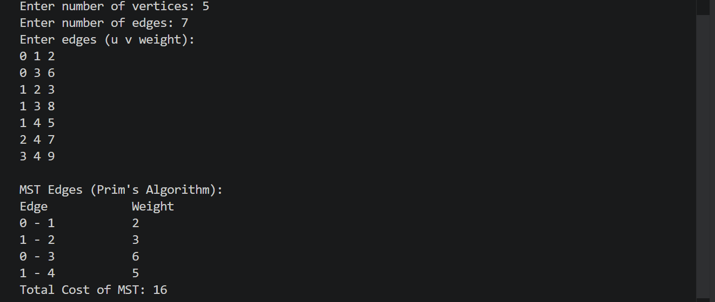

Program 2: Kruskal's Algorithm - MST using Sorted Edges

File Name:
q2_kruskals.c

Program Code:
#include <stdio.h>
#include <stdlib.h>
#define MAX 100
struct Edge {
int src, dest, weight;
};
struct Edge edges[MAX * MAX];
struct Edge mst[MAX];
int parent[MAX];
int rank[MAX];
int edgeCount = 0;
int find(int x) {
if (parent[x] != x)
parent[x] = find(parent[x]);
return parent[x];
}
void unionSets(int x, int y) {
int px = find(x);
int py = find(y);
if (rank[px] < rank[py])
parent[px] = py;
else if (rank[px] > rank[py])
parent[py] = px;
else {
parent[py] = px;
rank[px]++;
}
}
int compareEdges(const void* a, const void* b) {
return ((struct Edge*)a)->weight - ((struct Edge*)b)->weight;
}
int main() {
int vertices, numEdges, u, v, w;
printf("Enter number of vertices: ");
scanf("%d", &vertices);
printf("Enter number of edges: ");
scanf("%d", &numEdges);
printf("Enter edges (u v weight):\n");
for (int i = 0; i < numEdges; i++) {
scanf("%d %d %d", &u, &v, &w);
edges[i].src = u;
edges[i].dest = v;
edges[i].weight = w;
}
qsort(edges, numEdges, sizeof(struct Edge), compareEdges);
for (int i = 0; i < vertices; i++) {
parent[i] = i;
rank[i] = 0;
}
int mstEdges = 0;
int totalCost = 0;
for (int i = 0; i < numEdges && mstEdges < vertices - 1; i++) {
int pu = find(edges[i].src);
int pv = find(edges[i].dest);
if (pu != pv) {
mst[mstEdges++] = edges[i];
totalCost += edges[i].weight;
unionSets(pu, pv);
}
}
printf("\nMST Edges (Kruskal's Algorithm):\n");
printf("Edge\t\tWeight\n");
for (int i = 0; i < mstEdges; i++) {
printf("%d - %d\t\t%d\n", mst[i].src, mst[i].dest, mst[i].weight);
}
printf("Total Cost of MST: %d\n", totalCost);
return 0;
}

Sample Test Input:
Enter number of vertices: 5
Enter number of edges: 7
Enter edges (u v weight):
0 1 2
0 3 6
1 2 3
1 3 8
1 4 5
2 4 7
3 4 9

Expected Output:
MST Edges (Kruskal's Algorithm):
Edge Weight
0 - 1 2
1 - 2 3
1 - 4 5
0 - 3 6
Total Cost of MST: 16

Output Screenshot:
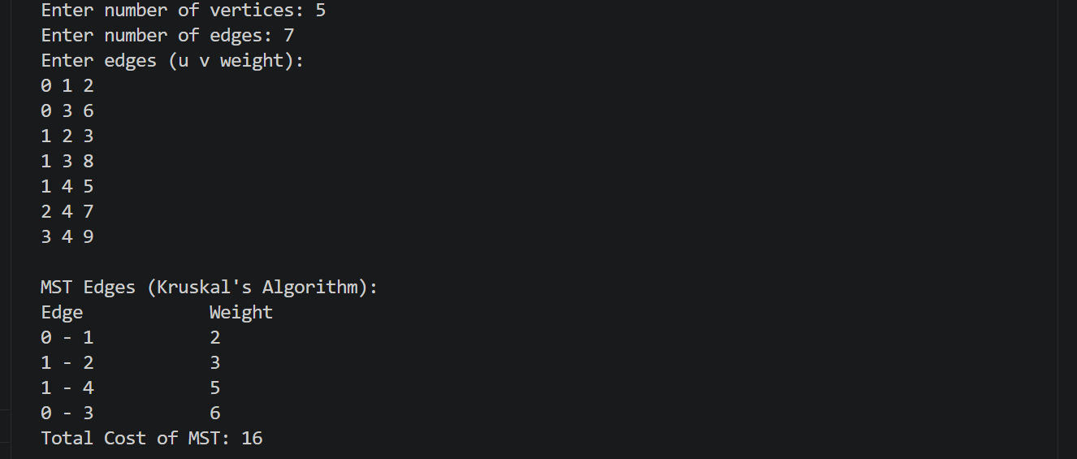

Program 3: Dijkstra's Algorithm - Shortest Path from Source

File Name:
q3_dijkstra.c

Program Code:
#include <stdio.h>
#include <limits.h>
#define MAX 100
int vertices;
int adjMatrix[MAX][MAX];
int dist[MAX];
int visited[MAX];
int prev[MAX];
int minDist() {
int min = INT_MAX, minIndex = -1;
for (int v = 0; v < vertices; v++) {
if (!visited[v] && dist[v] < min) {
min = dist[v];
minIndex = v;
}
}
return minIndex;
}
void printPath(int dest) {
if (prev[dest] == -1) {
printf("%d", dest);
return;
}
printPath(prev[dest]);
printf(" -> %d", dest);
}
void dijkstra(int src) {
for (int i = 0; i < vertices; i++) {
dist[i] = INT_MAX;
visited[i] = 0;
prev[i] = -1;
}
dist[src] = 0;
for (int count = 0; count < vertices - 1; count++) {
int u = minDist();
if (u == -1)
break;
visited[u] = 1;
for (int v = 0; v < vertices; v++) {
if (!visited[v] && adjMatrix[u][v] && dist[u] != INT_MAX &&
dist[u] + adjMatrix[u][v] < dist[v]) {
dist[v] = dist[u] + adjMatrix[u][v];
prev[v] = u;
}
}
}
}
int main() {
int edges, u, v, w, src, dest;
printf("Enter number of vertices: ");
scanf("%d", &vertices);
printf("Enter number of edges: ");
scanf("%d", &edges);
for (int i = 0; i < vertices; i++)
for (int j = 0; j < vertices; j++)
adjMatrix[i][j] = 0;
printf("Enter edges (u v weight):\n");
for (int i = 0; i < edges; i++) {
scanf("%d %d %d", &u, &v, &w);
adjMatrix[u][v] = w;
adjMatrix[v][u] = w;
}
printf("Enter source vertex: ");
scanf("%d", &src);
dijkstra(src);
printf("\nShortest distances from vertex %d:\n", src);
printf("Vertex\t\tDistance\n");
for (int i = 0; i < vertices; i++) {
if (dist[i] == INT_MAX)
printf("%d\t\tINFINITY\n", i);
else
printf("%d\t\t%d\n", i, dist[i]);
}
printf("\nEnter destination vertex: ");
scanf("%d", &dest);
if (dist[dest] == INT_MAX) {
printf("No path from %d to %d.\n", src, dest);
} else {
printf("Shortest Path from %d to %d: ", src, dest);
printPath(dest);
printf("\nTotal Distance: %d\n", dist[dest]);
}
return 0;
}

Sample Test Input:
Enter number of vertices: 5
Enter number of edges: 7
Enter edges (u v weight):
0 1 2
0 3 6
1 2 3
1 3 8
1 4 5
2 4 7
3 4 9
Enter source vertex: 0
Enter destination vertex: 4

Expected Output:
Shortest distances from vertex 0:
Vertex Distance
0 0
1 2
2 5
3 6
4 7
Shortest Path from 0 to 4: 0 -> 1 -> 4
Total Distance: 7

Output Screenshot:
